**From Art To Poetry**

**Original Artwork**

**Becomes**

**Original Poems**

**By**

**The Class**

**Of 2018**

**The Plea of The Peel** –By Bartosz Skiba

You see me laying on the floor

Yet you want nothing more

My arms are open wide

But your legs open up a wider stride

You chose to avoid me before and now

Yet you do not really know how

You classify me as a fall

I wish that was something I could control

My peel is open for your loving heart

If only you were smart

Just because I am a peel

Does not mean that I do not feel

I may symbolize pain and falling

But that does not classify me as appalling

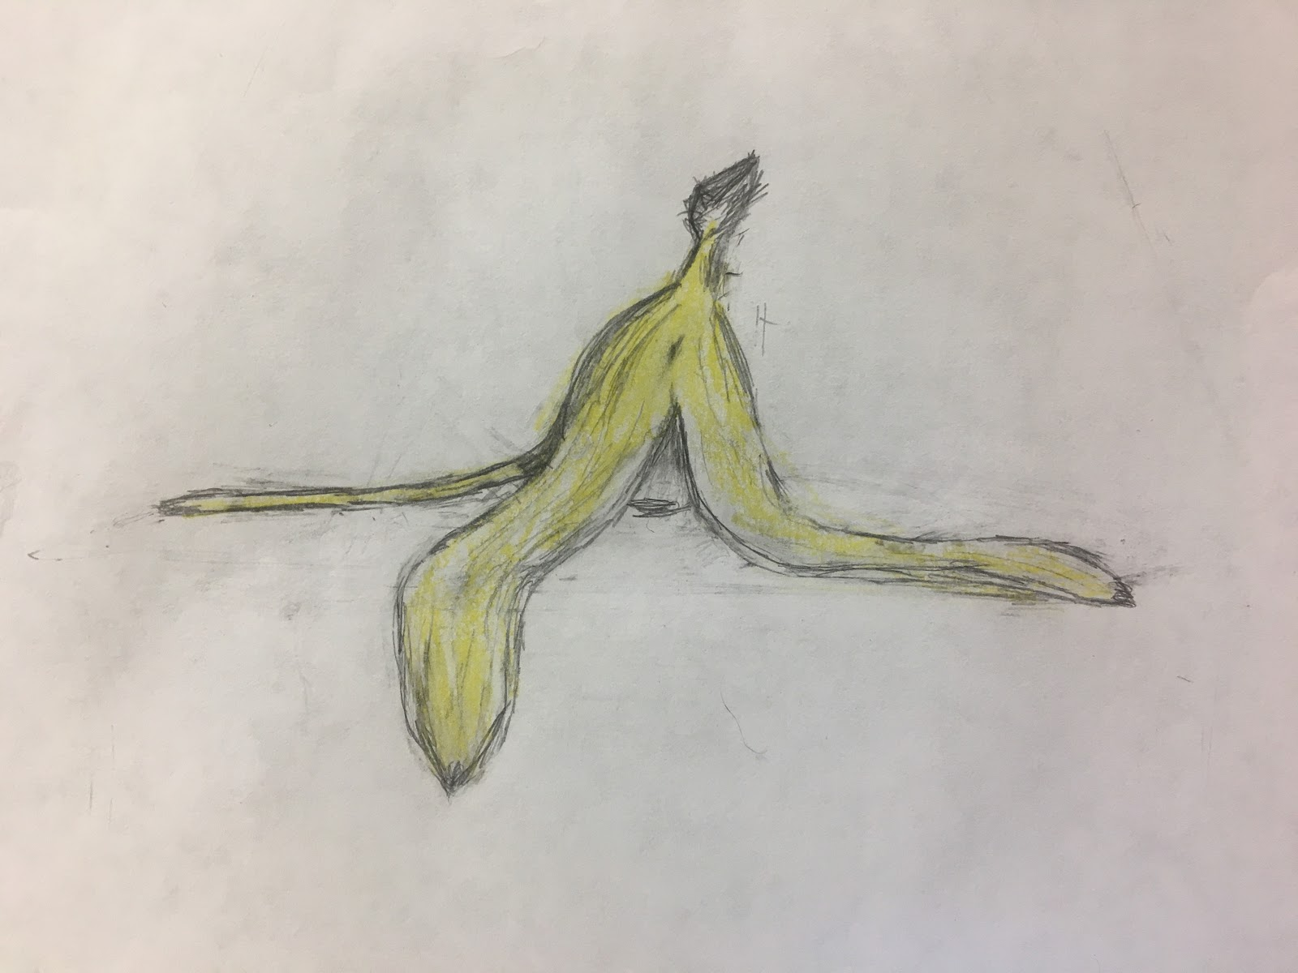

**The Balancing Act – By Elizabeth Kuriakose**

It teeters in a perfect balance

The book between my hands.

Too far left or too far right,

Determines if it stands.

The watch strapped around my wrist keeps counting

Tick tock tick tock tick tock

Inside my chest, my heart keeps pounding

Witnessing the splendid balancing act.

**How Fortunate**- By Farrah Rahman

How fortunate the sky is blue

That we don’t have to look too hard

To find an answer, sure and true,

Our minds need not be jarred.

But outer space, they say, is black,

Because the daytime sky is not,

Relax and let your senses slack,

Unseeing eyes let rot.

Look twice! Look thrice! For your own answer.

Speckled stars, celestial dancers,

42, a galactic cat--

Vast space is so much more than that.

So don’t contentedly allow

The wiser men with silver brow

To dictate how things truly are.

To weak eyes Sol’s the only star.

**Devil’s Eye**—by Ian Li

A whirlwind of color, swirling about,

Draining into an abyss,

Round but multidimensional,

warping time and space.

It engulfs and absorbs observers both literally and mentally,

Its rays clutch at you

like arms of spaghetti flailing about in every direction.

This is no escape after peering at the eye.

The damage is already done.

The devil has also stared you back.

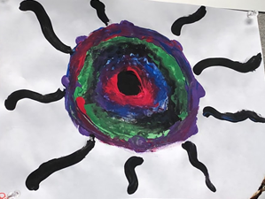

**Alone-**-By Jonathan Wong

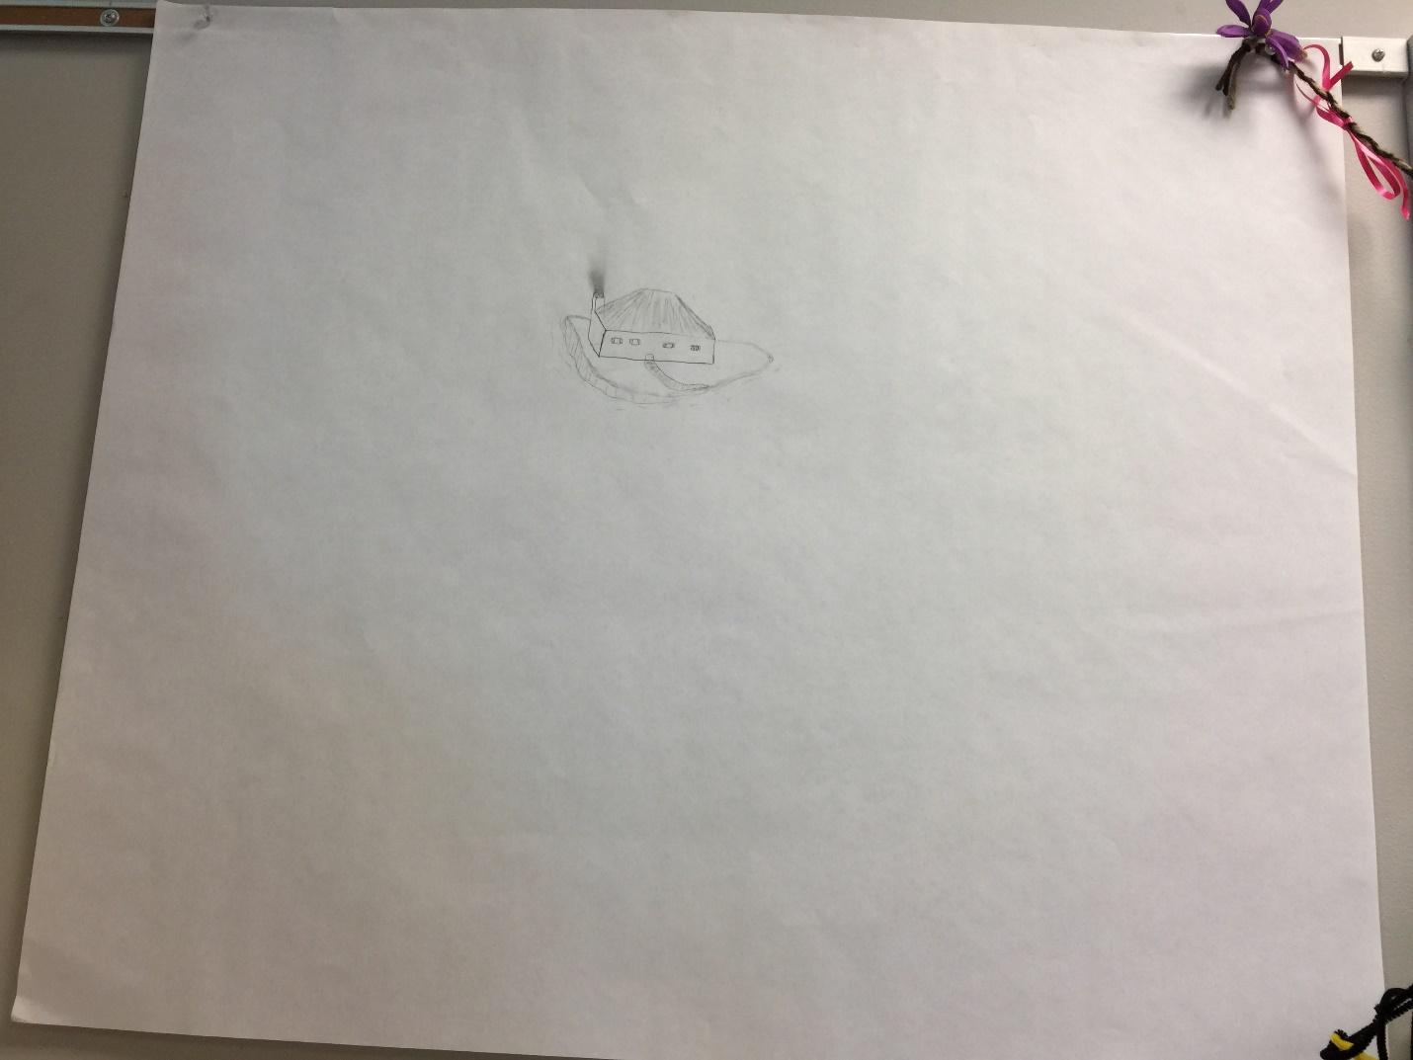

Alone in the big, wide world,

The fence separates as it is curled.

There is so much around,

Yet nothing to be found.

In this lonely dwelling,

There is no telling

If it could be seen

From a mile or thirteen.

Is there anybody else here?

I’ve looked above and below, nothing near.

Am I alone in this dimension?

What happened to all of creation?

**Branches of a Tree**—BY Lucent Fong

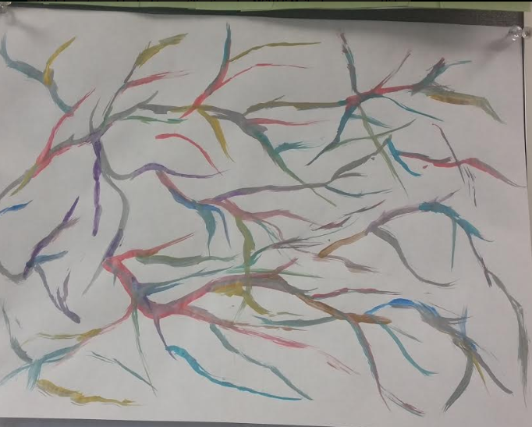

They say I’m cluttering my mind

Like one pollutes the river

But I can’t leave a single idea behind

Like alcohol in the liver

My thoughts continue to split

Like branches of a tree

I’m told my philosophy doesn’t fit

But I’ll set my colors free

Who knows if god wired our brain

How our neurons connect and spread

But if we keep our thoughts simple and plain

Might as well count ourselves dead

**Feathered Bird**--by Mark Byrnes

Here I sat inside a cage,

Chirping chirping yet they don’t

hear. Drawing me to a page,

focusing on my feathers

So then I began to sing

and then they would tune their ears

A fiction song of a king,

from someone in a dungeon.

All I wanted was to fly,

yet I did not even try.

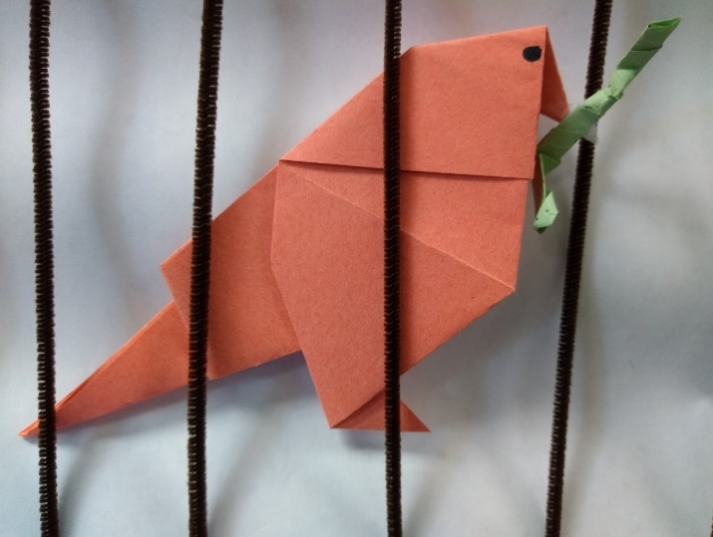

**Banana Poem** --  Matthew Chou

Eaten and discarded

It lays upon a table

Drooping o’er its edges

It waits for nature’s grasp

To reclaim it

To return it back to dust

To become one again

But until then

It waits upon its table

Waiting patiently for its time

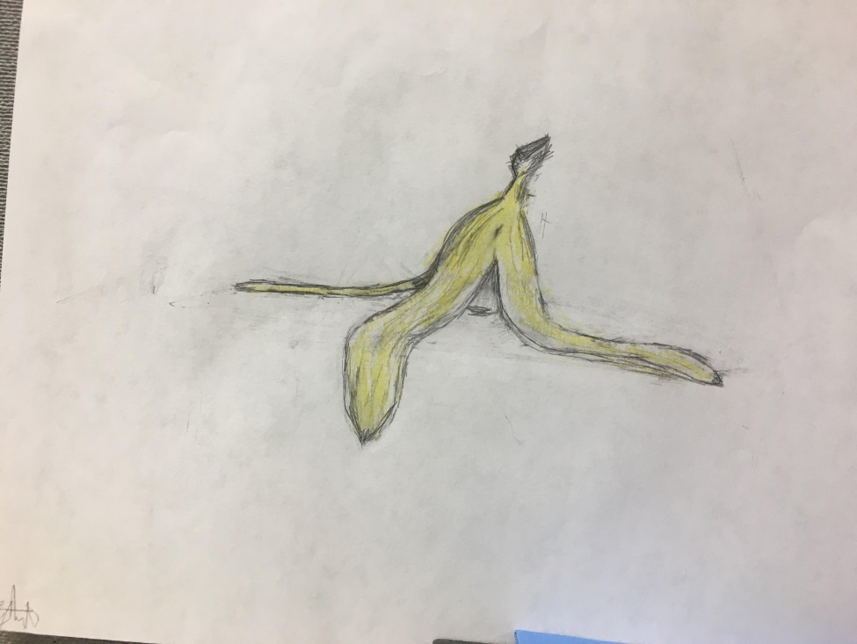- Art by Zachary Acosta

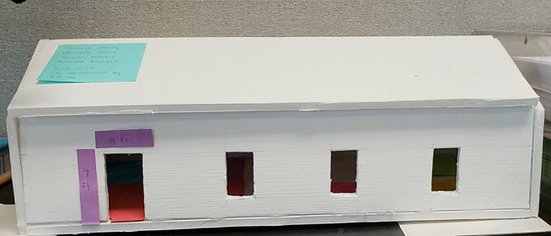

**4 Walls and A Roof**—By Swetha Ramesh

A little white house

With the woman in the blouse

Early morn she moves on

She tosses and turns, all before dawn

With utmost care the plates get placed

With little haste

She sets the table

Sits and reads a fable

Awaiting her love and loved ones

He daughters and sons

Yet no one sits with her

Because in that little white house

No one murmurs

But her

**The Moon Over the Sea**—By Abhishek Hariharan

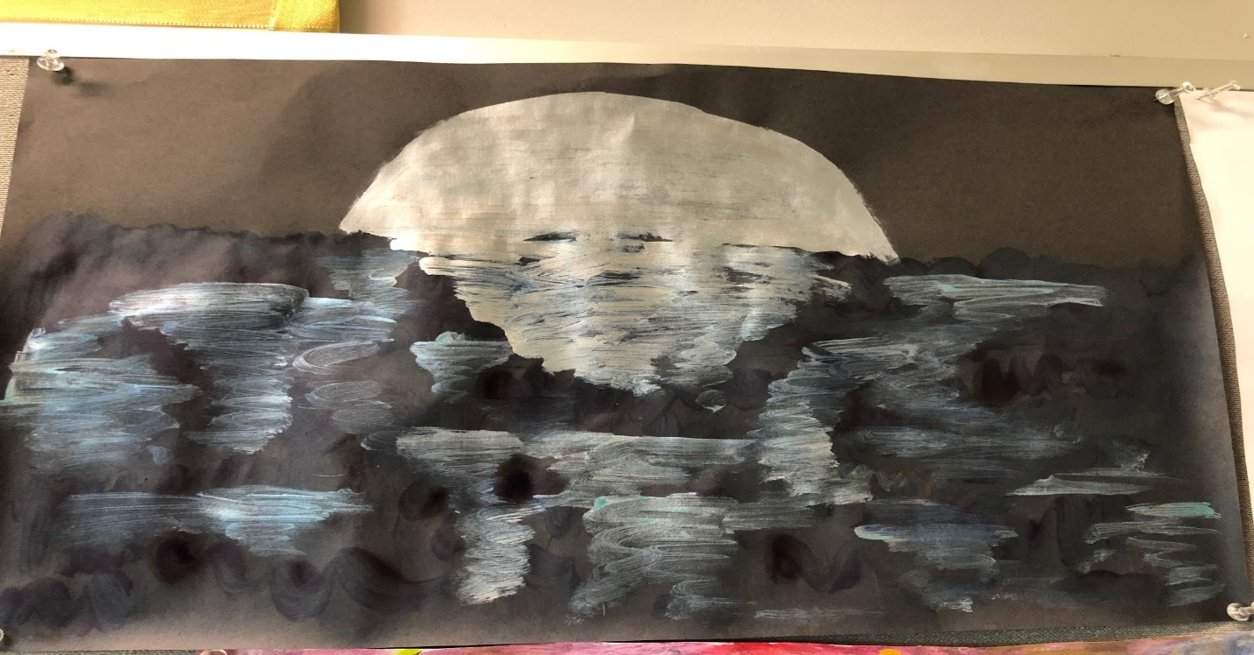

There lies the fair lunar glow,

Shining bright as the sea begins to flow.

And there is not a single soul

Amidst the shadows that are dark as coal.

For all bask in the glory of that glorious pearl up in the sky,

It was a sight that would bring forth from everyone a joyful cry…

The water rippled and trembled, buzzing with excitement and awe,

The clouds were stirred and parted away, free from their thaw.

And the hidden creatures of the lake began their lunar dance,

Their eyes pointed up to the sky, as if they were in a trance…

And as time went on, the moon began to melt…

Into the hearts of all those present; oh, how it felt!

A wave of pure emotion and power,

Still delicate and tranquil, but standing tall as a tower…

That elegant, magnificent moon, risen above the sea…

Given all those who view it a chance to be… free.

**Flowers in an Empty Field**—Abhishek Patel

Flowers in an empty field

The blades of grass a mighty shield

Clear skies with nothing to hide

Such immense beauty that he cried

Memories of a simpler past

Grass moved while the wild blew fast

No sun in sight but oh so bright

An empty palate with internal light

His soul was a palace but empty inside

All but two pink flowers had gone and died

Misery and sadness were their names

The grass was long to cover up the shame

A star reborn, there was time for rebirth

Growing from the ground, a brand new earth.

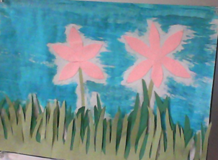

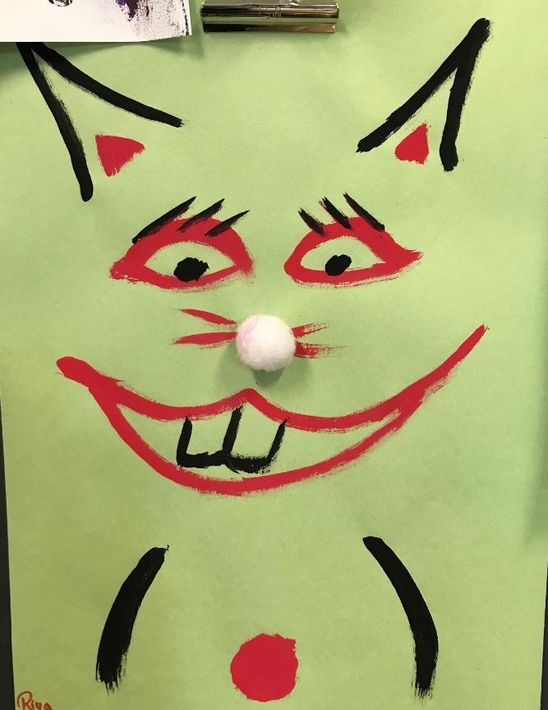**Cat Clown**—Allison Wong

Have you heard of the crazy cat clown?

He stares at you with bloodshot eyes

With his ears he can hear every sound

So don’t bother to try and hide

His nose is a fluffy cotton ball

But it’s not worth it to go near him

He has two buck teeth, big and all

And he’s not afraid to maul with them

His grin is so very, very wide

Let’s hope you don’t see him tonight

**Inside**-- Anjali Bothra

Tracing back our lineage

We all stem from the same root

We were once mighty creatures

Our scales - skin, a claw - foot

Our children's children’s children’s children

Will evolve even more

Maybe they’ll be leprechauns

We were dinosaurs

And if you look hard enough

With your heart and not your eyes

The mighty dinosaur still lives

Deep within, inside.

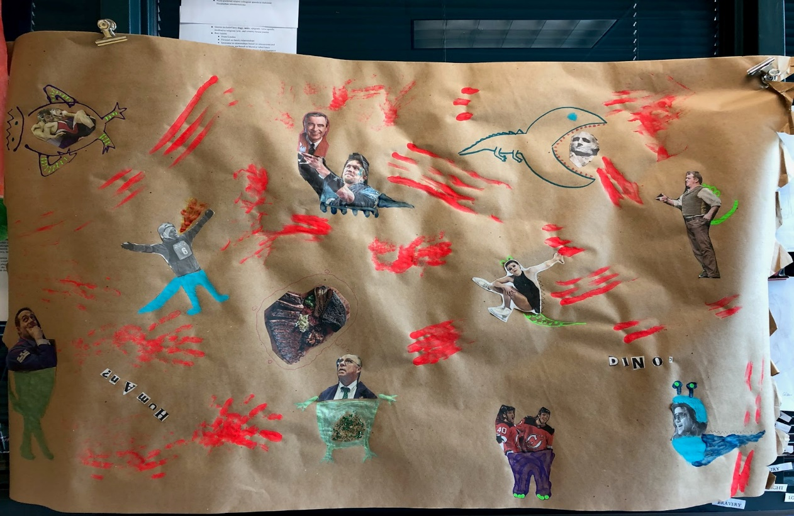

**Human or Dino**—Ankit Patel

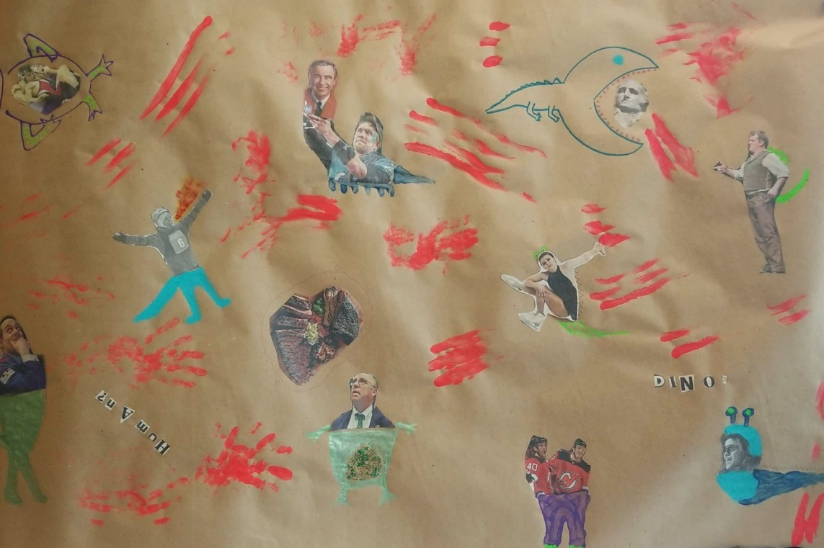

Human or dino?

What separates the ‘civilized’ disciples of Kipling,

From savage *tyrant Kings* who rule by killing?

We raise our most kind,

Only to tear through theme, berate them, puncture them,

And say when their legacies are discarded, “for shame then.”

Truths we hold to be self-evident,

Are eaten up and torn in gizzards when they lose appeal,

Regurgitated and force-fed to those who accept blind zeal.

We preach to do no harm,

But when we are done pretending and are filled with hunger,

Little stop us from killing and grilling ourselves a burger.

So little is different,

We lack the tails, teeth, and tough skin to show,

But at the least we ask,  “Am I human or dino?”

**From the Same Peg**—Jessica Hernandez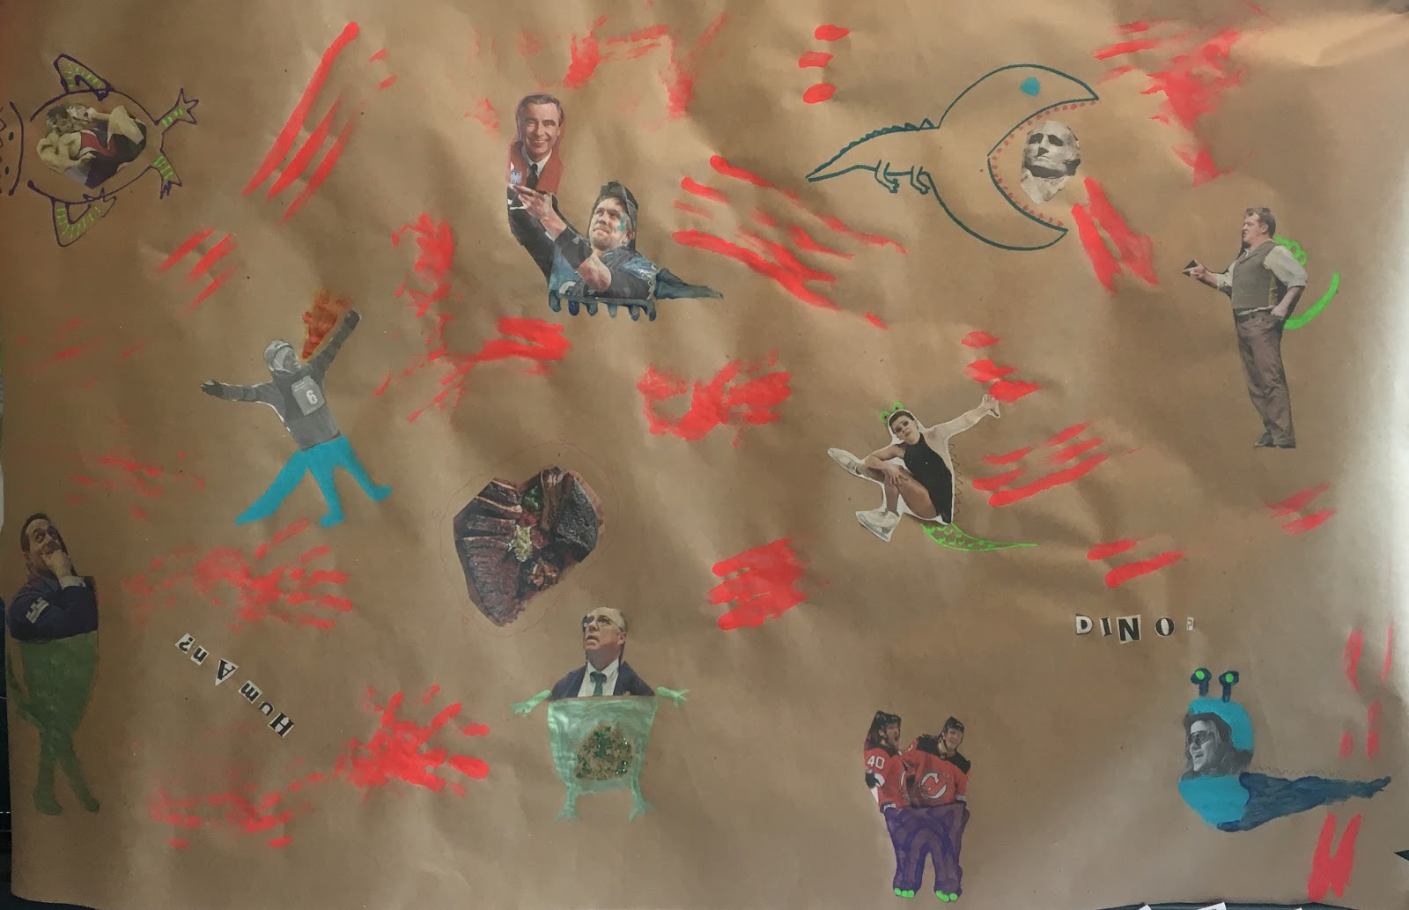

Human? Dino?

What do I know?

Ever since the world began,

What became intentions of man?

Our creation started with an egg,

We all have jumped from the same peg.

And yet we choose to forget this,

Making hate through differences.

We all reach up with separate aims,

Our skills and dreams in different frames.

It can not change how we are bred,

Our roots still shine as bright in red.

A human, a Dino,

I hope that I know.

Ever since the world began,

Together we've been known as man.

**Willowing Winds**-- Anjali Gupta

A mix of color, a little spice!

Blue and pink streaks like the tails of some mice.

In the willowing winds

The trees stand in shades of some blinds.

I see some magic, a little music!

Who knew the skies could be quite so acoustic?

Colors blend to create a sight,

A world so connected can only be seen in the night.

Some bits could perhaps be smoother,

But each equally important for the future.

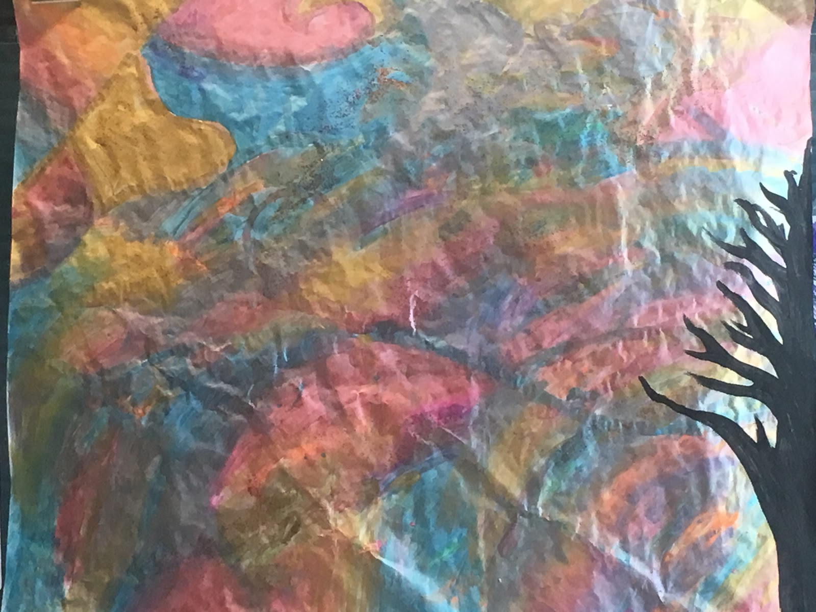

**Moonlight Fading**-- Anusha Nagar

Moonlight fading in the night

Not a creature left in sight

Half the moon above the earth

And from the ground a disastrous birth

Darkness swelled and took control

Humanity was plunged into the darkest of holes

Shadows slithered through the dark

Not a sound if you stopped to hark

The stars in the sky were nowhere to be seen

But there was another mystery if you were to be keen

As the morning rose and the night fell to the grounds

The creatures had returned to make their sounds.

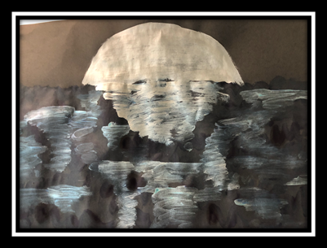

Pools of Liquid Memory

By Julie Pirro

Pools of liquid memory

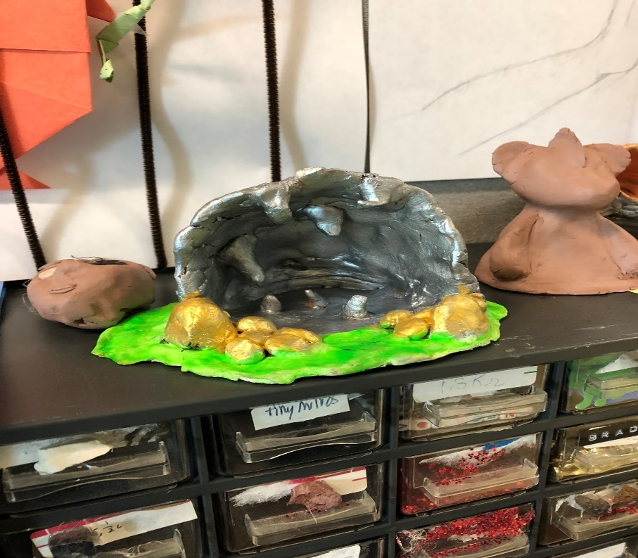Dripping in my mind;

A cave of light and reverie,

A cave of slip and slime.

I stumble, slowly, still,

Through thick, lethargic time.

My hands no longer kill;

They hold what was once mine.

Steady, nostalgic waves

Beating my insides;

I sit in nostalgic caves

And watch the time slide by.

**A Lone Bug**-- By Kamakashi Sharma

A lone bud

nesting in the barren forests

hidden under the shades of the trees & the shrouds of the night

A single petal

branching out

separating from its dormant hive

curling back into the shades of the trees & the shrouds of the night

One by one

floral by floral

staining a mysterious red in the shades of the trees & the shrouds of the night

So beautiful, such grace

enticing, almost like a siren

pulling you in with song of the shades of the trees & the shrouds of the night

A full bloom

in all its scarlet, golden glory

welcoming your presence as you marvel at the beauty

shimmering & moving to encase you and your starry eyes from the shades of the trees & the shrouds of the night

A silent death

blood staining the petals, feeding the crimson hue

gold glowing inside the closing blossom

a beauty looming death into the shades of the trees & the shrouds of the night

**Twelve**-- Kelley Chau

Twelve faces, thirty edges, twenty vertices,

A dodecahedron is

Like the earth, but flawed-

Jagged corners and edges

Differentiate me.

Five vertices, five edges,

A pentagram is

Like the sun, but defined-

Straight lines and sharp angles

Characterize me.

In unity they form a world,

Star dodecahedron.

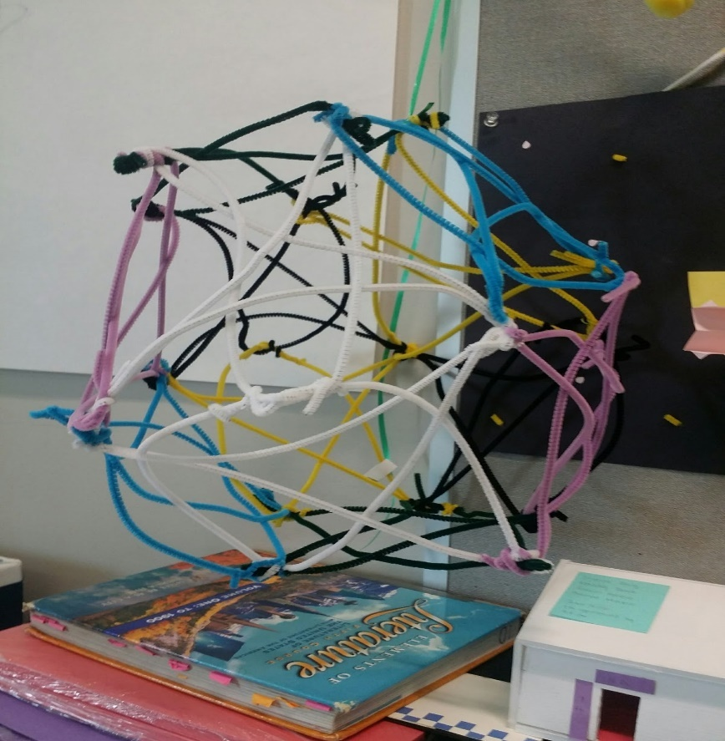

**Banana Peel-- By Khushi Gandhi**

The layers reveal many

For many, the inside is hard to see

See that the outside means nothing

Nothing without what one truly is

The finest clothes and jewelry and more

More and more just for show

Show not your wealth but rather happiness

Happiness with the person you are

Character and personality show reality

Reality cannot be hidden by pel

Peel away the perfect yellow

Yell out when you see the rotten

Without the person remains only the peel

Peel that one can slip on

Only is we look at the outside

Outside out comfort but we must

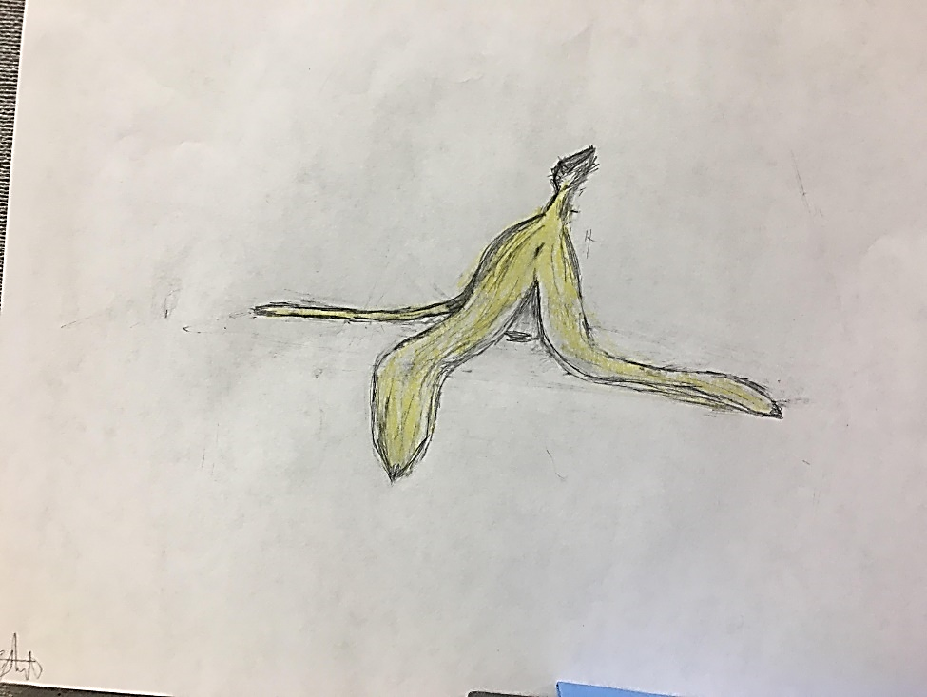

**Poem-- Kunal Adhia**

The man who’s lived a thousand lives

And had his share of friends and wives

Knows no perfection save his work

Yet his mind won’t fail to lurk.

A world with infinite land

From rolling hills to forts on sand

With city lights and grazing space,

The man must choose his time and place.

Yet all he wants is escape from flaws,

A perfect place, devoid of laws.

Yet the only place he could find

Was emptiness to satisfy his mind.

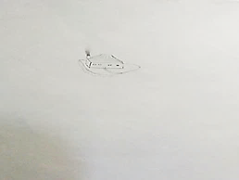

Our Love’s Song-- Malavika Vivek

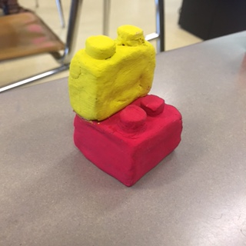

Fitting together, hand in mine

Mismatched but mingling still

Whirlwind of beautiful love combined

Together at last, our hearts fill

Passion and friendship

Found in red and yellow

An emotional journey, rollercoaster trip

Hands meet, a renewed hello

So different - different places and times

But sometimes different makes us strong

You look at me again and my heart chimes

Comfortable silence, our love’s song

**Your Light** By: Rohan Mehra

Among the sea of darkness you emerge as light

An absolute hope that can overcome any despair

A silver lining that breaks through a thunderstorm’s might

A smile and look of gold to show everyone that you care

Your words of pure white enrich the gloom that pervades

Unleashing a force of glimmers oppressed by the black

The dark fights back to ensure that all light fades

But you rallied the powers of light and began the attack

Although this is just the beginning and the dark stands strong

The birth of your light reveals that a world of pure black is wrong

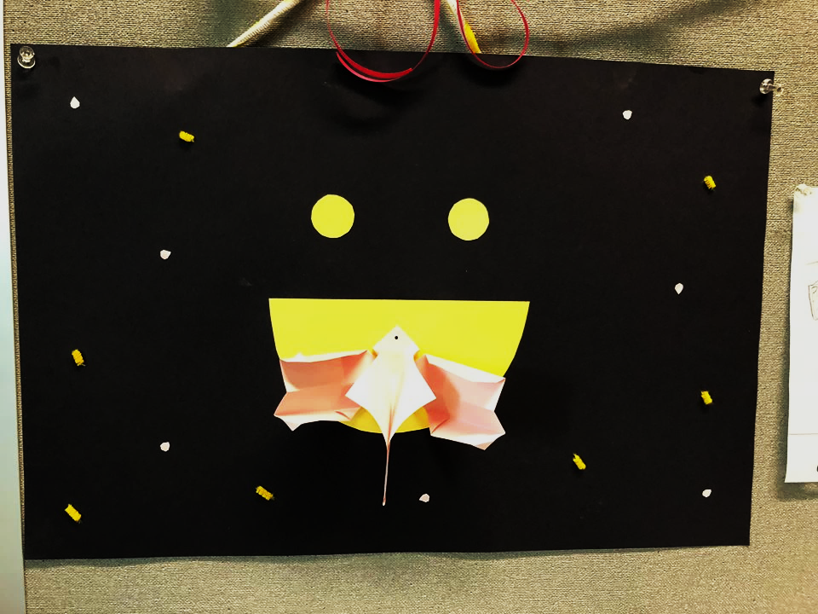

**Appendicles**—Samuel Carlos

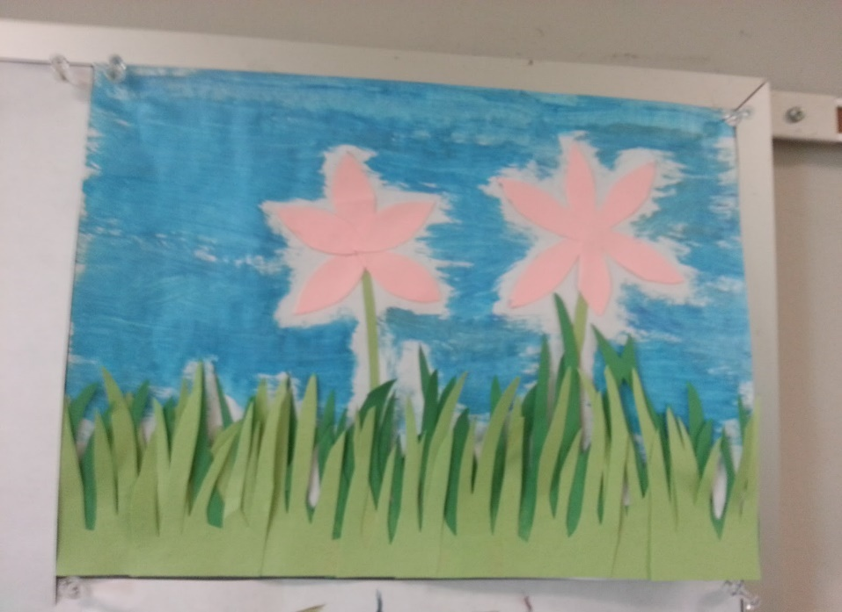

The blades of grass flap in the wind.

Allowed to grow, they are untrimmed.

Behind them sits two pink flowers,

Standing tall like two tall towers

You would think they’re identicals,

But unlike are their appendicles.

Under dark blue sky, they remain,

Calmly waiting for drops of rain.

But until that one rainy day,

The blades of grass and flowers stay.

-<http://www.dictionary.com/browse/appendicle> small appendages

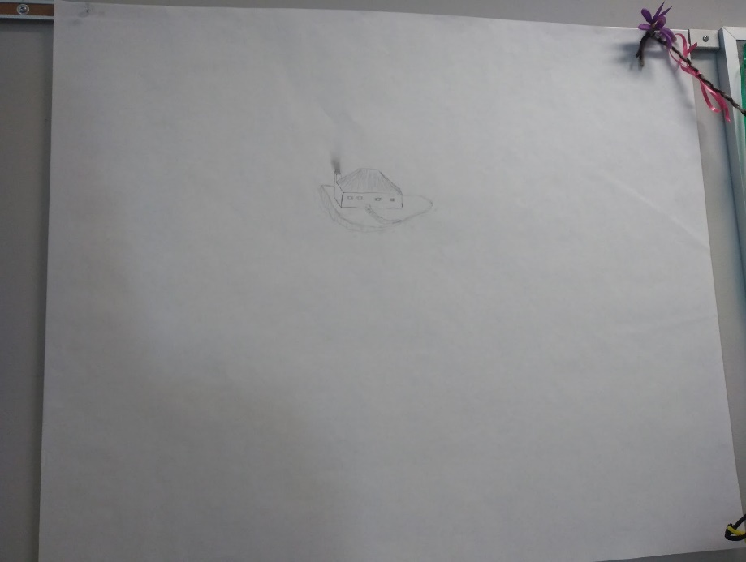

**Two Sides**-- Zarir Hamza

A blank white canvas has nothing but a home

To someone that home is a refuge to come back to

Hours are spent trying to walk back from his roam

In the end, there is nothing to do

Except coming back tired and alone.

A blank white canvas has nothing but a place

To someone that place is nothing but a prison cell

Hours are spent trying to escape and pace

In the end, nothing is done in this hell

Except coming back tired and alone